Question : The class diagram represents the structure of a school results application where students have subjects, and their scores are calculated for grades.

**Diagram Description:**

* **Classes**: Student, Subject, GradeCalculator
* **Relationships**:
  + A Student has multiple Subject entries (Aggregation).

GradeCalculator computes the results for a Student.

Solution:

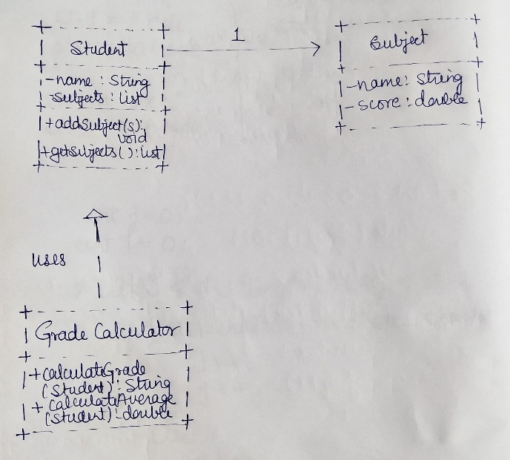

Question:An object diagram provides a snapshot of the Student and their Subject objects at a particular point.

**Example:**

* **Student**: John
* **Subjects**: Maths, Science
* **Marks**: 90, 85

Solution:

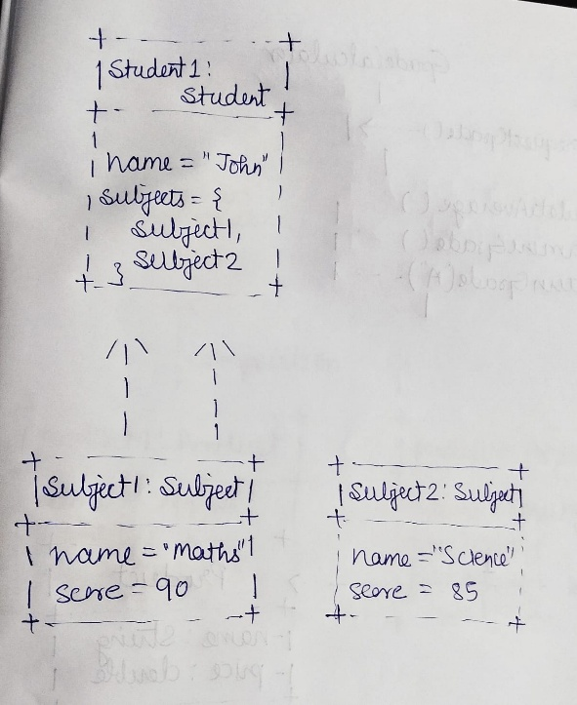

Question:The sequence diagram shows how objects interact to calculate grades.

**Scenario:** A student requests their grade based on marks in subjects.

**Actors:**

1. Student
2. GradeCalculaton

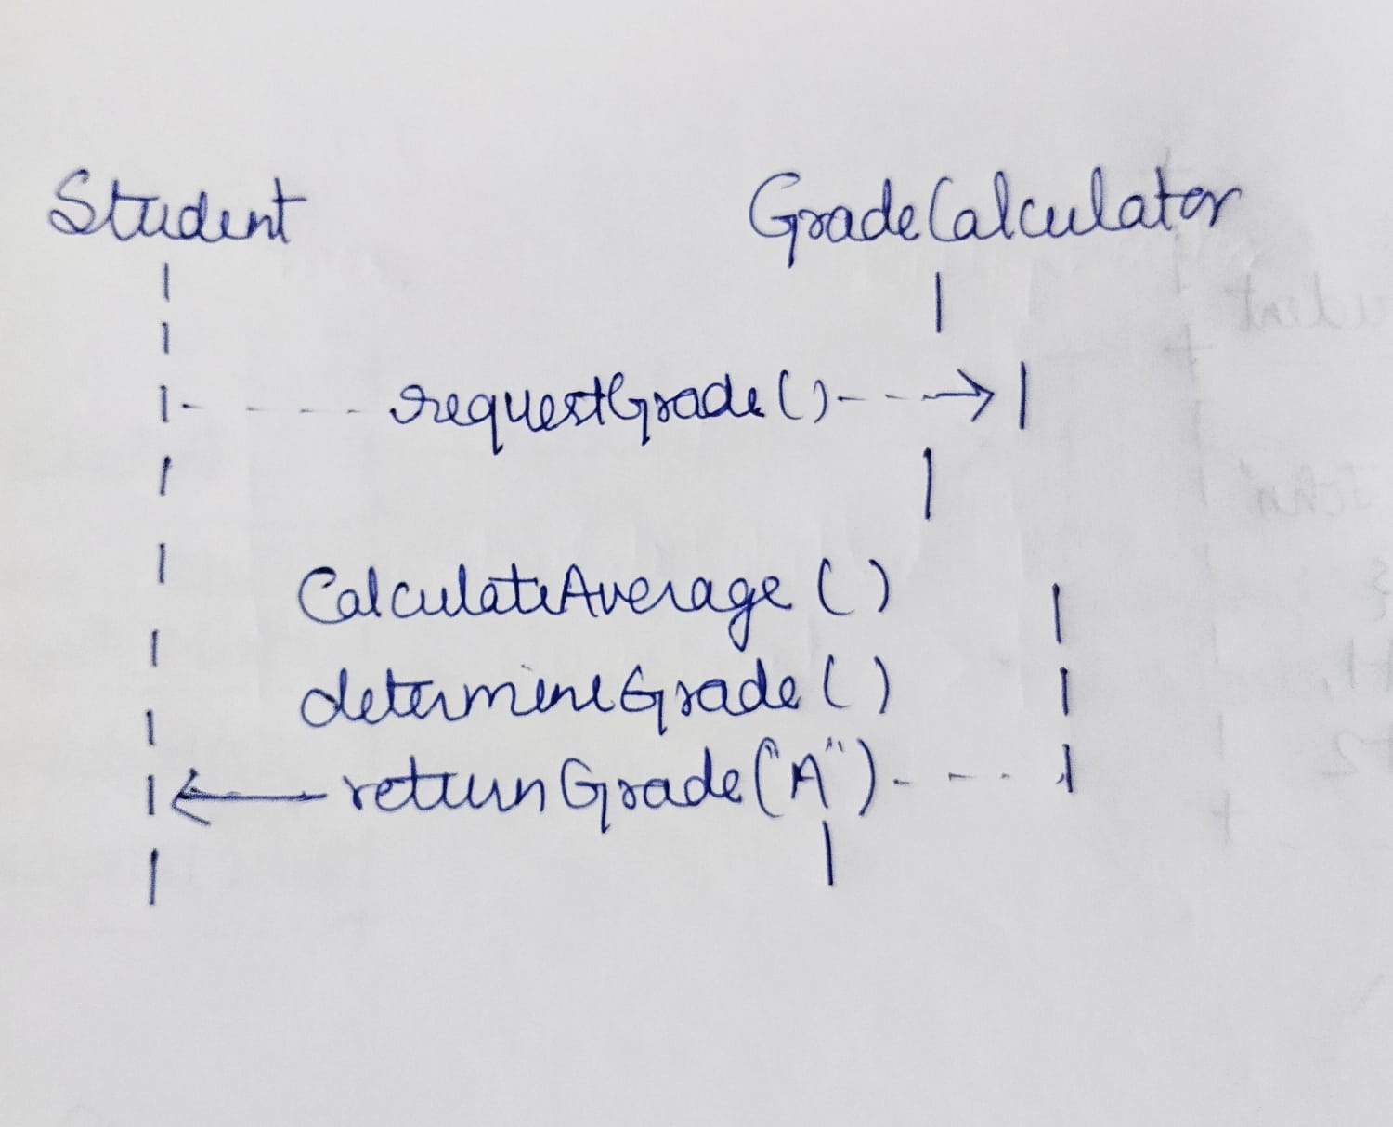

Question:The class diagram models the system where a customer buys products, and the bill is generated.

**Diagram Description:**

* **Classes**: Customer, Product, BillGenerator
* **Relationships**:
  + A Customer can purchase multiple Product items (Composition).

BillGenerator computes the total for the Customer.

Solution:

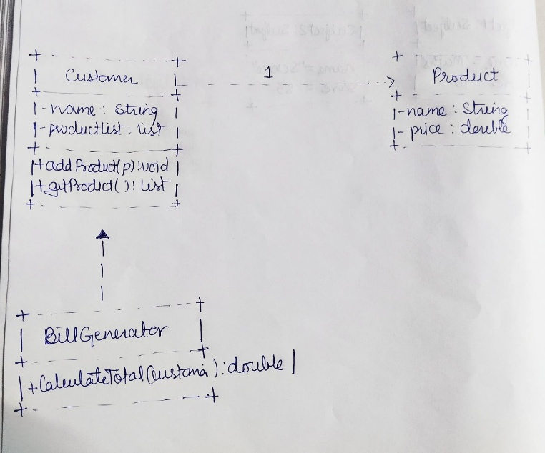

Question:An object diagram shows the details of a Customer and the Product objects they have purchased.

**Example:**

* **Customer**: Alice
* **Products**:
  + Apples (2 kg at $3 per kg)
  + Milk (1 liter at $2 per liter)

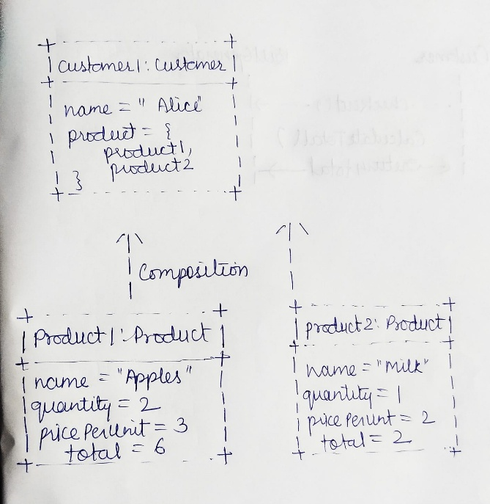

Question:The sequence diagram shows the process of bill generation for a customer.

**Scenario:** A customer checks out at the grocery store, and the total bill is generated.

**Actors:**

1. Customer
2. BillGenerator

